How to Get a Russian Visa?
Step 1
Choose the type of the Russian visa you would like to have.
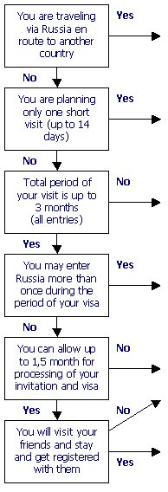 | You need  a transit visa!  You need  a tourist visa!  You need  a business  multiple  entry visa!  You need  a business  double  entry visa!  You need  a business  single  entry visa!  You need  a private visa!
Step 2
Send us an application form to Get an invitation for the type of the Russian visa you have chosen.
Step 3
Get the Russian visa itself from a Russian Embassy/Consulate (кликая эту ссылку, мы должны попасть на список Русских консульств – список здесь www.russianembassy.net) in your city.

